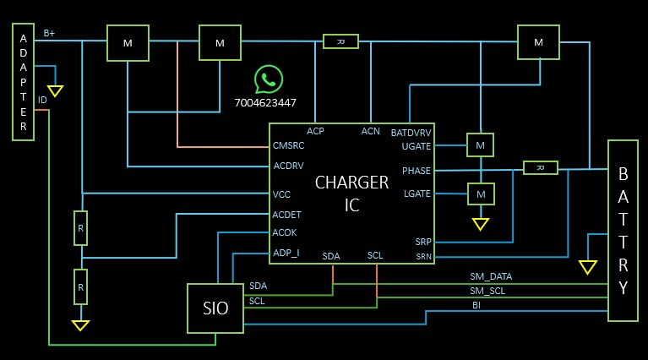
- Adapter ID Pin
Charger ID PIN SIO ko batati hai ki kitne WATT 45/65 ki adapter lagi hui hai.
- Agar CMSRC nhi detect hui to, ACDRV banna band ho jayegi.
- Battery charging ke liye LDO banana Jaruri hai.
- Battery Charging Requirements
BIOS (LDO 3.3 v honi chahiye pull ke through)
SIO (LDO3.3 v honi chahiye pull ke through)
Battery Present (LDO honi chahiye pull ke through - high hai to low aur low hai to high)
- SM_DATA (LDO3.3 v honi chahiye pull ke through)
- SM_SCL(LDO3.3 v honi chahiye pull ke through)
- BI (LDO3.3 v honi chahiye pull ke through).
- AC OK (LDO3.3 v honi chahiye pull ke through)
Note SIO ACOK ko read krta hai agar 3.3 volt hai to adapter connected aur 0volt to adapter not connected, battery se chalega.

✅ Sahi logic:
Adapter 19V
↓
Charger IC
↓
LDO 3.3V
↓
SIO / BIOS Active
↓
ACOK
↓
SMBUS Communication
↓
Battery Detect
↓
Charging Enable
↓
Battery Charging

Aur ye points bhi important hain:
- ACOK = 3.3V → Adapter Connected
- ACOK = 0V → Adapter Not Connected
- SM_DATA aur SM_SCL par 3.3V pull-up hona chahiye
- Battery Present signal valid hona chahiye
- BIOS aur SIO powered hone chahiye

